|  |  |  |
| --- | --- | --- |
| EASTERN UNIVERSITY | | |
| Name | MD.Kamruzzaman |  |
| Student ID | 201400059 (CSE) |
| Semester | Spring-2022 |
| Blood Group | O+ |
| Contact | E-mail: [tanvir3430@gmail.com](mailto:tanvir3430@gmail.com), [kztanvirzaman@gmail.com](mailto:kztanvirzaman@gmail.com)  Mobile: 01759800150 |

**Computer Networking (Project ALPHA)**

NETWORK ADDRESS TABLE:

|  |  |  |  |  |
| --- | --- | --- | --- | --- |
| NETWORK ADDRESS | SUBNET MASK | ROUTER(IP) | SWITCH | VLAN (name)/DHCP |
| 192.168.0.0 | 255.255.255.0/24 | R1(192.168.0.1) | SW1 | 20(CNET20A) /(Tanvir20A) |
| 192.168.1.0 | 255.255.255.0/24 | R1(192.168.1.1) | SW1 | 40(CNET40B) /(Tanvir40B) |
| 192.168.2.0 | 255.255.255.0/24 | R1(192.168.2.1), R2(192.168.2.2) |  |  |
| 192.168.3.0 | 255.255.255.0/24 | R1(192.168.3.1), R4(192.168.3.2) |  |  |
| 192.168.4.0 | 255.255.255.0/24 | R3(192.168.4.2), R4(192.168.4.1) |  |  |
| 192.168.5.0 | 255.255.255.0/24 | R2(192.168.5.1), R3(192.168.5.2) |  |  |
| 192.168.6.0 | 255.255.255.0/24 | R3(192.168.6.1) | SW2 | 10(CNET10) / (DHCP R3 VLAN 30) |
| 192.168.7.0 | 255.255.255.0/24 | R3(192.168.7.1) | SW2 | 20(CNET20) / (DHCP R3 VLAN 30) |
| 192.168.8.0 | 255.255.255.0/24 | R3(192.168.8.1) | SW2 | 30(CNETServer30) / (DHCP R3 VLAN 30) |
| 192.168.9.0 | 255.255.255.0/24 | R4(192.168.9.1), R5(192.168.9.2) | SW3 | LAN STATIC ADDRESS |
| 192.168.10.0 | 255.255.255.0/24 | R2(192.168.10.1) | SW4 | 40(CNET40) / (DHCP R3 VLAN 30) |
| 192.168.11.0 | 255.255.255.0/24 | R2(192.168.11.1) | SW4 | 50(CNET50) / (DHCP R3 VLAN 30) |
| 192.168.12.0 | 255.255.255.0/24 | R5(192.168.12.1) | SW5 | DEFAULT VLAN 1 / (DHCP R3 VLAN 30) |

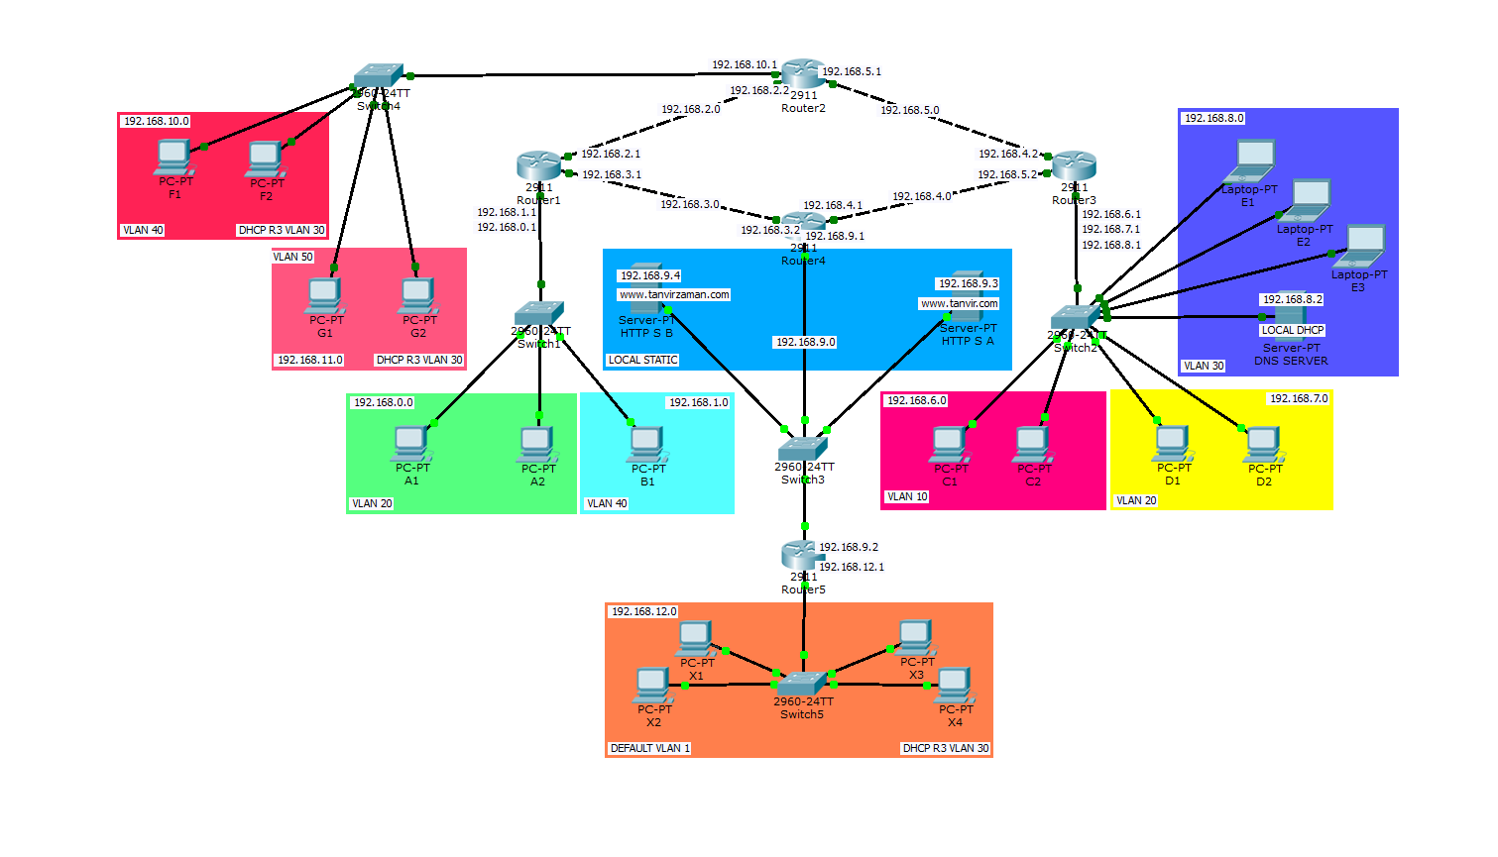ENTIRE NETWORK:

|  |  |
| --- | --- |
| **ROUTER 1** | **SWITCH 1** |
| enable  configure terminal  int gig0/0  no ip address  no shutdown  exit  int gig0/0.20  encapsulation dot1Q 20  ip address 192.168.0.1 255.255.255.0  exit  int gig0/0.40  encapsulation dot1Q 40  ip address 192.168.1.1 255.255.255.0  exit  int gig0/1  ip address 192.168.2.1 255.255.255.0  no shutdown  exit  int gig0/2  ip address 192.168.3.1 255.255.255.0  no shutdown  exit  ip dhcp pool Tanvir20A  network 192.168.0.0 255.255.255.0  default-router 192.168.0.1  dns-server 192.168.8.2  exit  ip dhcp pool Tanvir40B  network 192.168.1.0 255.255.255.0  default-router 192.168.1.1  dns-server 192.168.8.2  exit  ip dhcp excluded-address 192.168.0.1  ip dhcp excluded-address 192.168.1.1  router ospf 1  network 192.168.0.0 0.0.0.255 area 1  network 192.168.1.0 0.0.0.255 area 1  network 192.168.2.0 0.0.0.255 area 1  network 192.168.3.0 0.0.0.255 area 1  end | enable  configure terminal  vlan 20  name CNET20A  exit  vlan 40  name CNET40B  exit  int range fa0/1-2  switchport mode access  switchport access vlan 20  exit  int fa0/3  switchport mode access  switchport access vlan 40  exit  int gig0/1  switchport mode trunk  end |

|  |  |
| --- | --- |
| **ROUTER 2** | **SWITCH 4** |
| enable  configure terminal  int gig0/0  ip address 192.168.2.2 255.255.255.0  no shutdown  exit  int gig0/1  ip address 192.168.5.1 255.255.255.0  no shutdown  exit  int gig0/2  no shut  exit  int gig0/2.40  encapsulation dot1Q 40  ip address 192.168.10.1 255.255.255.0  ip helper-address 192.168.8.2  exit  int gig0/2.50  encapsulation dot1Q 50  ip address 192.168.11.1 255.255.255.0  ip helper-address 192.168.8.2  exit  router ospf 2  network 192.168.2.0 0.0.0.255 area 1  network 192.168.5.0 0.0.0.255 area 1  network 192.168.10.0 0.0.0.255 area 1  network 192.168.11.0 0.0.0.255 area 1  end | enable  configure terminal  vlan 40  name CNET40  exit  vlan 50  name CNET50  exit  int range fa0/1-2  switchport mode access  switchport access vlan 40  exit  int range fa0/3-4  switchport mode access  switchport access vlan 50  exit  int gig0/1  switchport mode trunk  end |

|  |  |
| --- | --- |
| **ROUTER 3** | **SWITCH 2** |
| enable  configure terminal  int gig0/1  ip address 192.168.4.2 255.255.255.0  no shutdown  exit  int gig0/0  ip address 192.168.5.2 255.255.255.0  no shutdown  exit  int gig0/2  no ip address  no shutdown  exit  int gig0/2.10  encapsulation dot1Q 10  ip address 192.168.6.1 255.255.255.0  ip helper-address 192.168.8.2  exit  int gig0/2.20  encapsulation dot1Q 20  ip address 192.168.7.1 255.255.255.0  ip helper-address 192.168.8.2  exit  int gig0/2.30  encapsulation dot1Q 30  ip address 192.168.8.1 255.255.255.0  ip helper-address 192.168.8.2  exit  router ospf 3  network 192.168.4.0 0.0.0.255 area 1  network 192.168.5.0 0.0.0.255 area 1  network 192.168.6.0 0.0.0.255 area 1  network 192.168.7.0 0.0.0.255 area 1  network 192.168.8.0 0.0.0.255 area 1  end | enable  configure terminal  vlan 10  name CNET10  exit  vlan 20  name CNET20  exit  vlan 30  name CNETServer30  exit  int range fa0/1-2  switchport mode access  switchport access vlan 10  exit  int range fa0/3-4  switchport mode access  switchport access vlan 20  exit  int range fa0/5-10  switchport mode access  switchport access vlan 30  exit  int gig0/1  switchport mode trunk  end |

|  |  |
| --- | --- |
| **ROUTER 4** | **ROUTER 5** |
| enable  configure terminal  int gig0/0  ip address 192.168.3.2 255.255.255.0  no shutdown  exit  int gig0/1  ip address 192.168.4.1 255.255.255.0  no shutdown  exit  int gig0/2  ip address 192.168.9.1 255.255.255.0  no shutdown  exit  router ospf 4  network 192.168.3.0 0.0.0.255 area 1  network 192.168.4.0 0.0.0.255 area 1  network 192.168.9.0 0.0.0.255 area 1  end | enable  config terminal  int gig0/0  ip address 192.168.9.2 255.255.255.0  no shutdown  exit  int gig0/1  ip add 192.168.12.1 255.255.255.0  ip helper-address 192.168.8.2  no shutdown  exit  ip dhcp excluded-address 192.168.12.1 192.168.12.250  router ospf 5  network 192.168.9.0 0.0.0.255 area 1  network 192.168.12.0 0.0.0.255 area 1  end |
| **SWITCH 3** DEFAULT | **SWITCH 5** DEFAULT |